4/27/2024

Study Finder

Project created by Jaden Williams, Deyandra Burke, Trinitee Jeffers, Jalen Richburg

Coote, Vanessa

Florida A&m University

**Table of Contents**

**Collection Reference Diagram...................................................................................................2**

**Data Flow Diagrams ...........................................................................................................3-4**

**Data Dictionary............................................................................5-6**

**Risk Register................................................................................7**

**Lessons Learned Report...............................................................................................................8**

**Collection Reference Diagram**

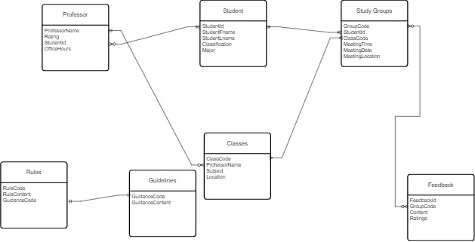

**Data Flow Diagrams**

Context Level Diagram

Simplified description of the interaction between Users and the Study Groups through the use of our System

Level 0 Diagram

Description of the processes and the different interactions with our application system

Level 1 Diagram

Detailed Description of the Interactions between the Users, Staff, and Databases found in our system. This includes a breakdown of the processes previously stated in the level 0 diagram.

**Data Dictionary**

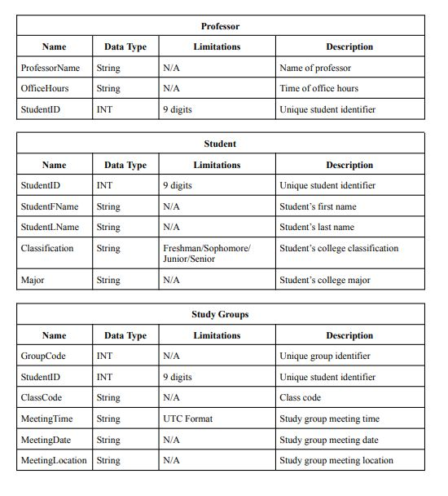

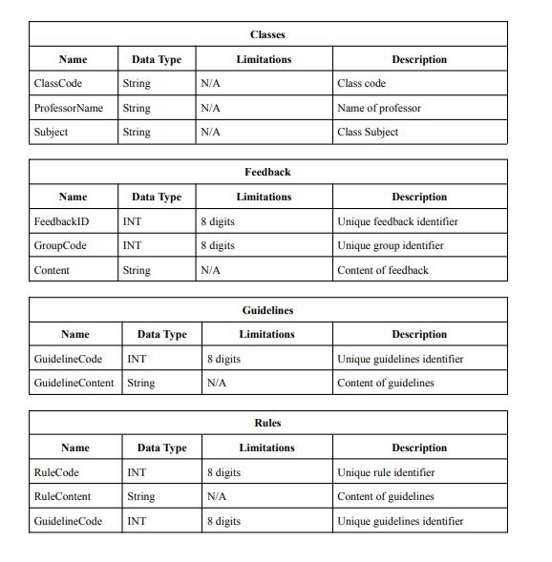

**Lessons Learned Report**

**Jaden**

Through designing this project, I've learned a lot, mainly about time management. Although I've known in the past that it is best to work on things ahead of time, this project emphasized that in a way that I have never experienced. When working on milestones, Breaking Them into steps at least three days beforehand made them much less daunting and easier to manage. In the future, I will look ahead to my tasks rather than just taking things as they come. I would prepare more.

**Jalen Richburg**

Throughout the project, I have learned several project management concepts and techniques to craft a compelling and well-thought-out project. In particular, this project taught me that scope creep is common but avoidable. Knowing when to stop is vital for creating application features. Additionally, I have learned more about working with a team and effectively completing deliverables remotely.

**Deyandra Burke:**

The class and group project provided practical skills for designing, developing, and deploying information systems professionally, enhancing teamwork, communication, and project management.

**Trinitee Jeffers**

During this design process, I have learned a lot about what goes into a project that I would not have considered. Many of the documents that we fielded were new to me, and I had to learn as I was creating them. This project also taught me how to work with my strengths while still being able to work on parts of the project I’m inexperienced with. In the future, I would take more notice of how the documents work with each other and start working on them earlier so I can use them to assist me.

**Presentation Recording**

[https://famu.zoom.us/rec/share/wEvfbiKXXYHjgzXFuQz5PhY3pnhMyIk5Y5Soa8oK3DyPg8lx1Xac3Pd30rgtLa0V.4yFEvS0yRXkCRgoF](https://nam11.safelinks.protection.outlook.com/?url=https%3A%2F%2Ffamu.zoom.us%2Frec%2Fshare%2FwEvfbiKXXYHjgzXFuQz5PhY3pnhMyIk5Y5Soa8oK3DyPg8lx1Xac3Pd30rgtLa0V.4yFEvS0yRXkCRgoF&data=05%7C02%7C%7Cad1b33e83a3d4d79d3f608dc67fc439d%7C2526db3cd5034dfea0e60c41a20b52d2%7C0%7C0%7C638499580362678924%7CUnknown%7CTWFpbGZsb3d8eyJWIjoiMC4wLjAwMDAiLCJQIjoiV2luMzIiLCJBTiI6Ik1haWwiLCJXVCI6Mn0%3D%7C0%7C%7C%7C&sdata=2%2F8AoQsMyX%2BsTPWnQ8JQW1wdu6B4vfsXFUCyDEm2pEc%3D&reserved=0)

**<https://youtu.be/BbOn_L-xqE4>**

References:

24.7 Study Together. (n.d.). Retrieved from

<https://www.studytogether.com/how-to-studytogether>

EdApp.  (n.d.). Retrieved from

<https://www.edapp.com/editable-elearning-content-library/>

Slack.  (n.d.). Retrieved from

<https://slack.com/features/channels>